*Set: Believe in yourself, don’t cheat*

**Name: Md. Rifat Ahmed**

**ID: 1931725042**

**Section: 7**

**Set: 3**

**Part 1:**

Construct the following circuit in Multisim where, *Vs = 10 (variable)*, diode is *virtual* and resistances are *470 ohm*, 220 ohm and 1 kilo ohm.

Measure the value of load voltage VL and complete the table 01.

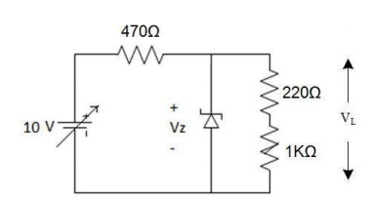

|  |  |
| --- | --- |
| V (volts) | VL (volts) |
| 1.0 | 721.844 mV |
| 3.0 | 2.166 V |
| 6.0 | 4.331 V |
| 8.0 | 4.958 V |
| 11.0 | 4.983 V |
| 12.0 | 4.988 V |
| 16.0 | 4.999 V |

Table 01

**Part 02:**

Attach the screenshots of the constructed circuit during the measurement of VL when Vs = 16 V. (below)

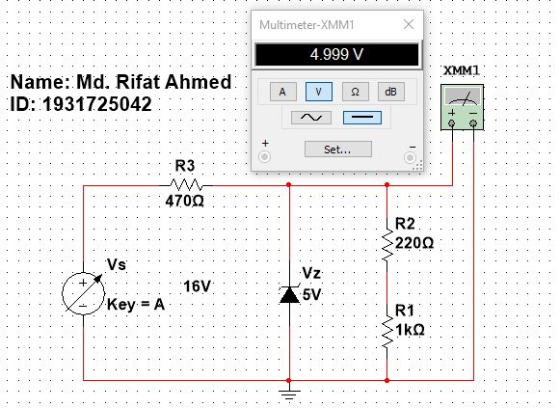

Figure – Circuit when Vs = 16V

**Part 03:**

Answer the following questions in your own words**.**

1. What is the name of the experiment?

Ans: Zener Diode Applications (Load Regulation)

1. What happens to the load voltage when Vs increases? And why?

Ans: When Vs increases the Load voltage also increases but the virtual diode used here is 5V so when more than 5V is applied in the Vs the voltage across the load is still close to 5V and cannot cross it as in reverse bias the Zener diode only lets a fixed amount of Voltage pass through it so through the load the same amount will pass.

1. What is the name and code of this 1 credit course?

Ans: Analog Electronics Lab (EEE111L)

1. What is the function of the diode used in this circuit?

Ans: The function of Zener diode used in this circuit is Regulating Load.

1. What was the Zener voltage rating we used in the lab?

Ans: 5V